Sample Cisco Spark Communication Plan

1) Imported cisco spark communication plan (edited "slack" communication plan)

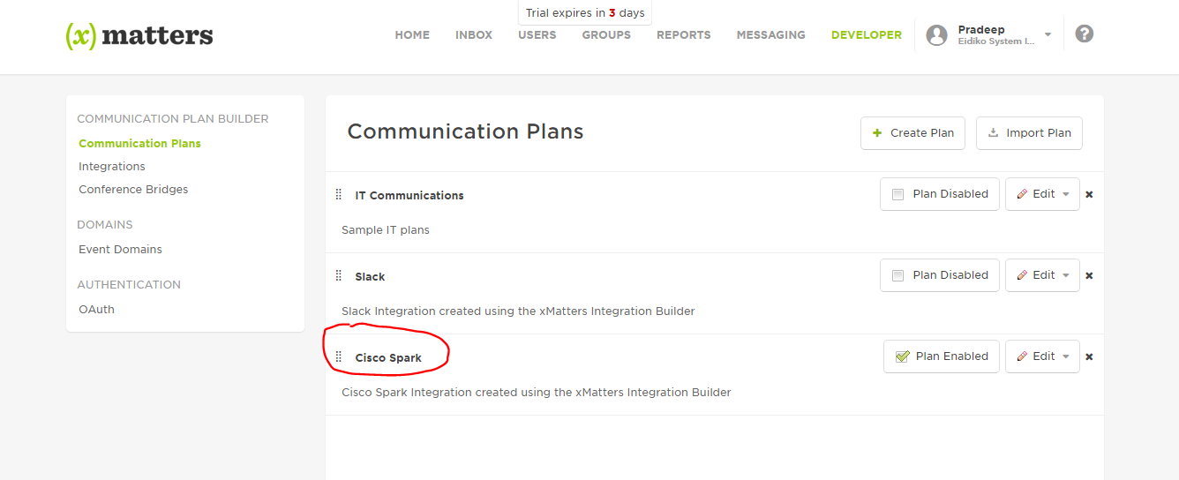

2) Sample form looks like following

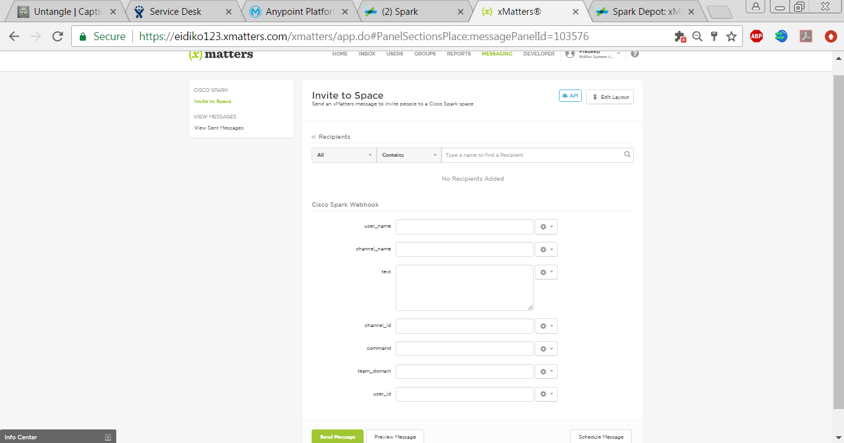

3) Added inbound and outbound integrations

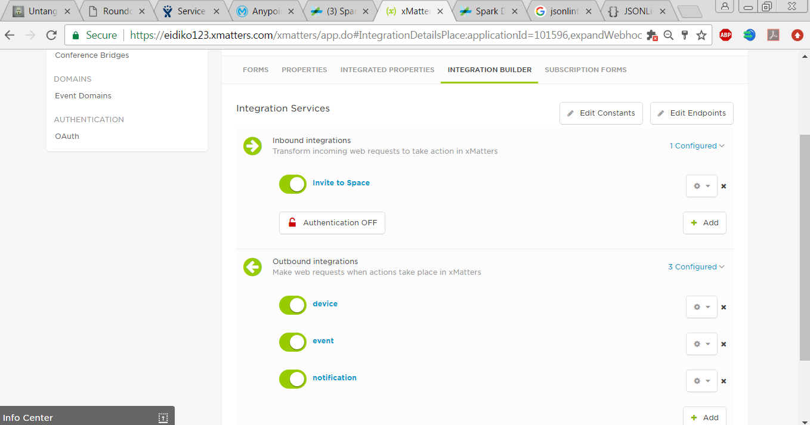

4) Just took sample data and hit through postman

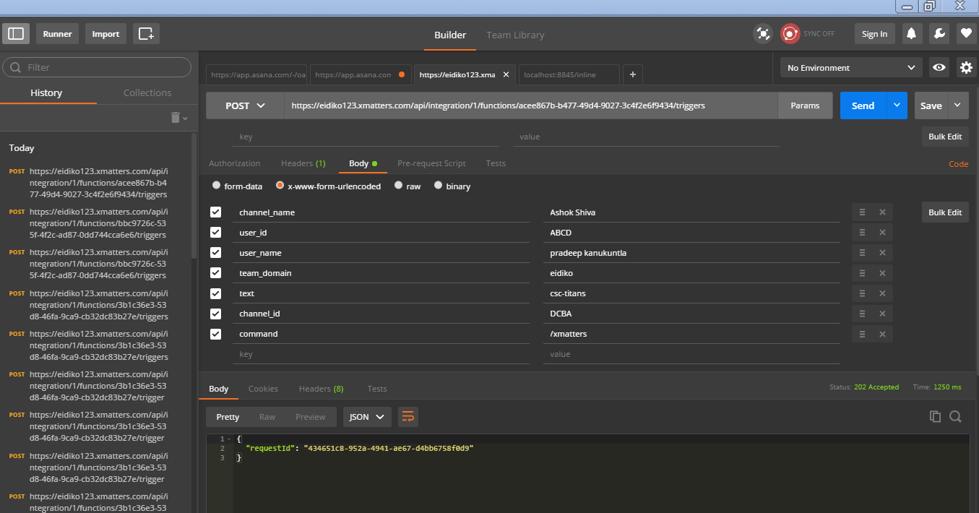

5) Responses in xmatters

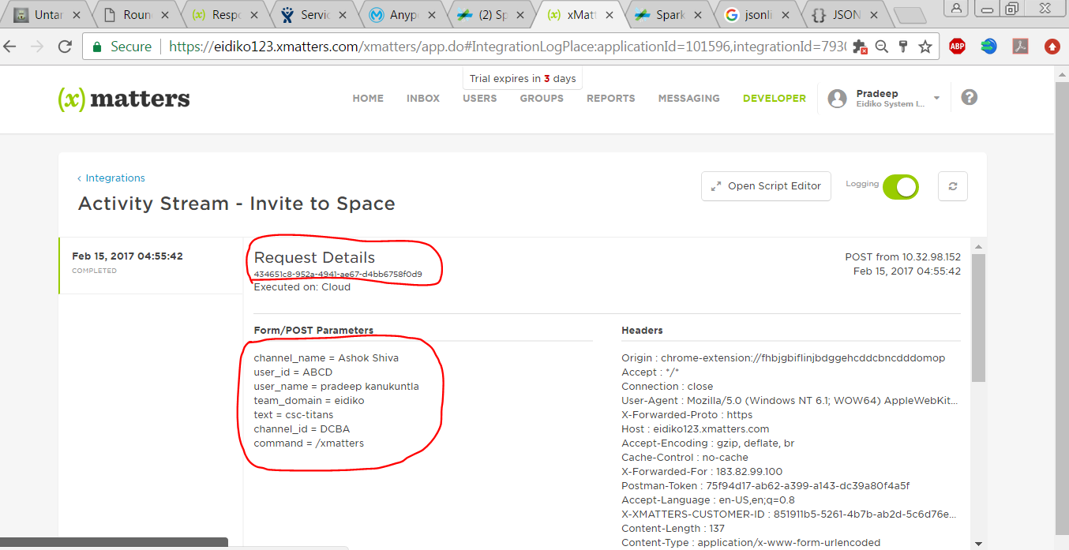

6) Inboud integration triggered an incident

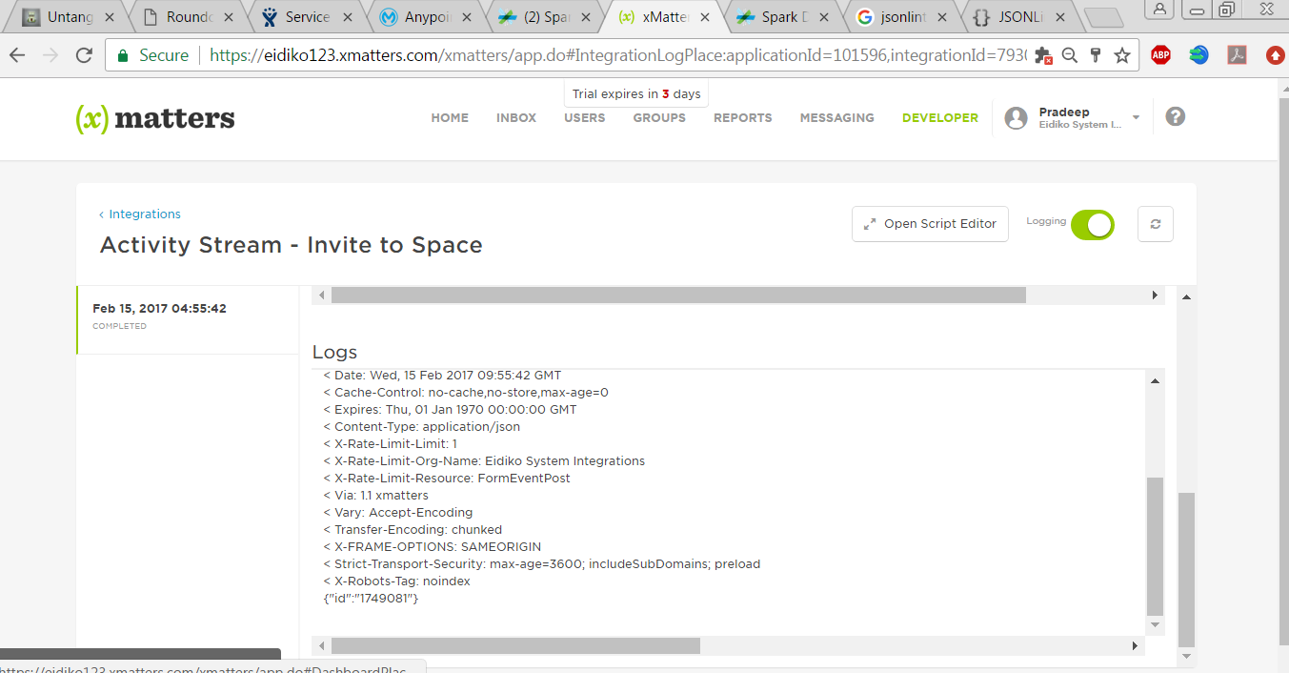

7) Event status and device delivery messages in spark

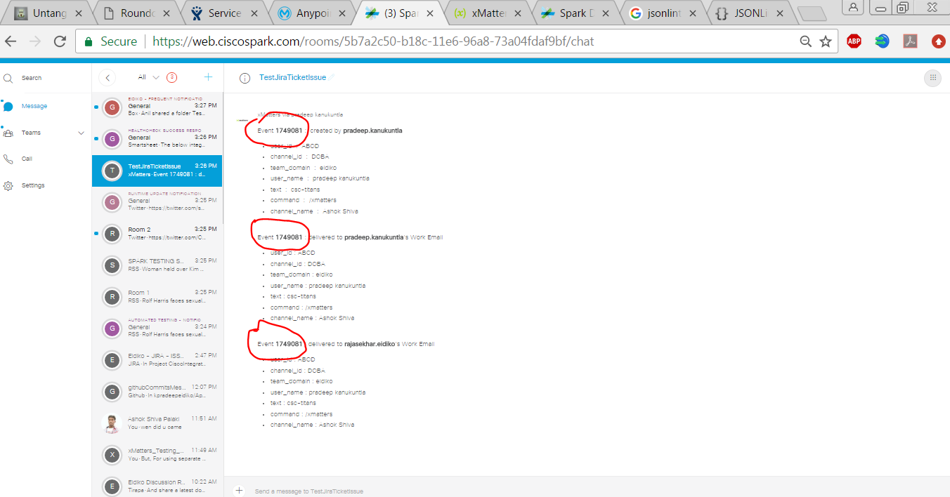

8) Email from xMatters

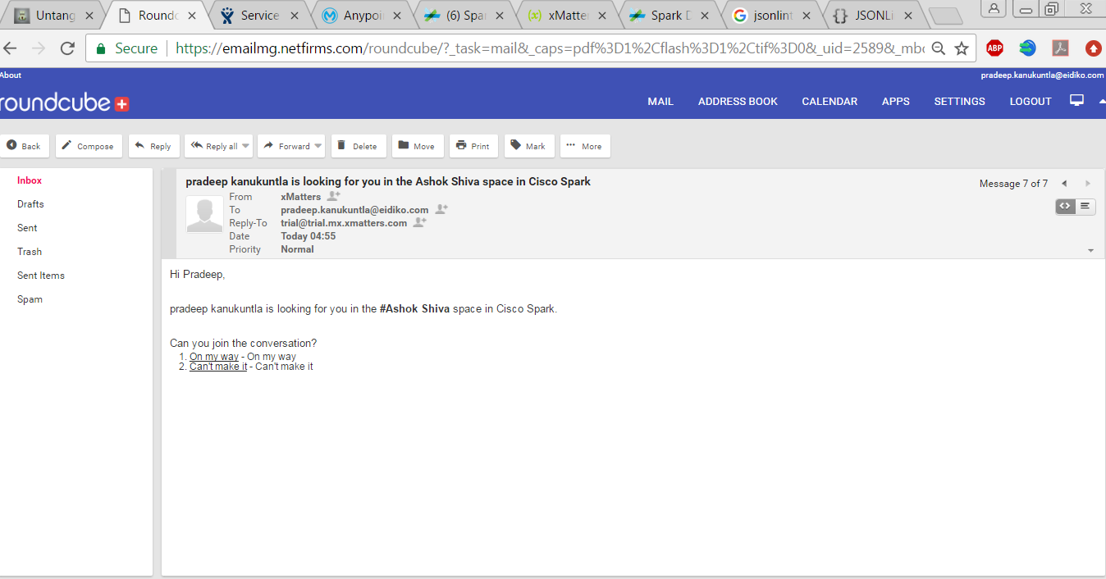

9) Responded from email : message in spark

